Varun V
192412628

EXPERIMENT 8
clc;
clear;
close all;

% Steering Angles (degrees)
angle = [-60 -30 0 30 60];

% Normalized Gain
gain = ones(size(angle));

% Create Polar Plot
figure;
polarplot(deg2rad(angle), gain, 'o-', 'LineWidth', 2);

% Add Title
title('Steering Angle Variation in MIMO Beamforming');

% Optional: Set radial limits
rlim([0 1.2]);

% Optional: Add grid
grid on;
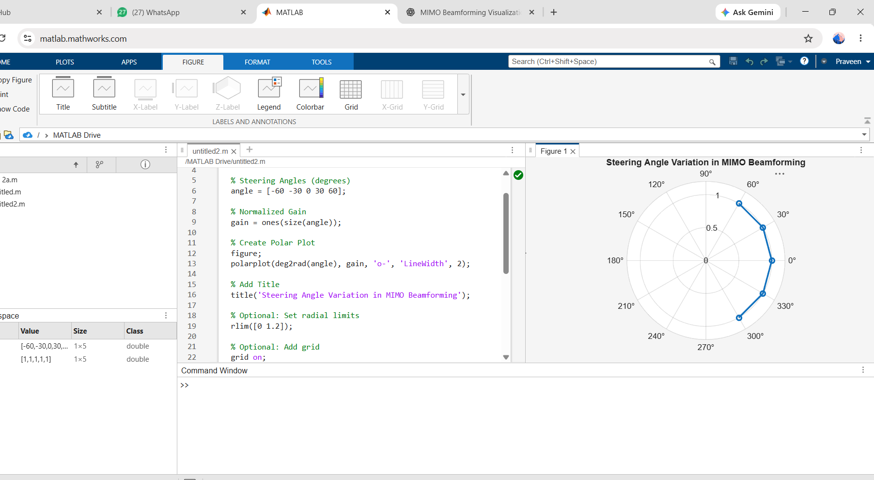

OBJ 1
clc;
clear;
close all;

% Steering Angles (degrees)
angle = [-60 -30 0 30 60];

% Array Gain (dB)
gain = [9 12 15 12 9];

% Create Bar Graph
figure;
bar(angle, gain);

% Add Grid and Labels
grid on;
xlabel('Steering Angle (Degrees)');
ylabel('Array Gain (dB)');
title('Array Gain for Different Steering Angles');
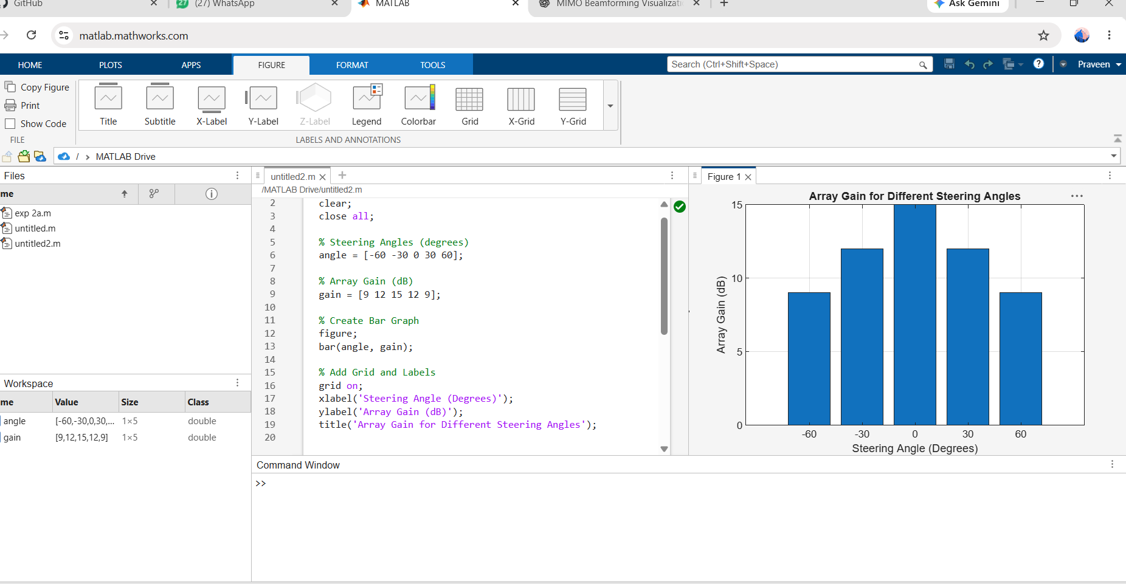
OBJ 2
clc;
clear;
close all;

% Desired Steering Angles (degrees)
desired = [-60 -30 0 30 60];

% Actual Beam Directions (degrees)
actual = [-58 -32 1 29 62];

% Beam Direction Error (Absolute Error)
error = abs(desired - actual);

% Plot Beam Direction Error
figure;
plot(desired, error, 'o-', 'LineWidth', 2);

grid on;
xlabel('Desired Steering Angle (Degrees)');
ylabel('Beam Direction Error (Degrees)');
title('Beam Direction Error for Different Steering Angles');
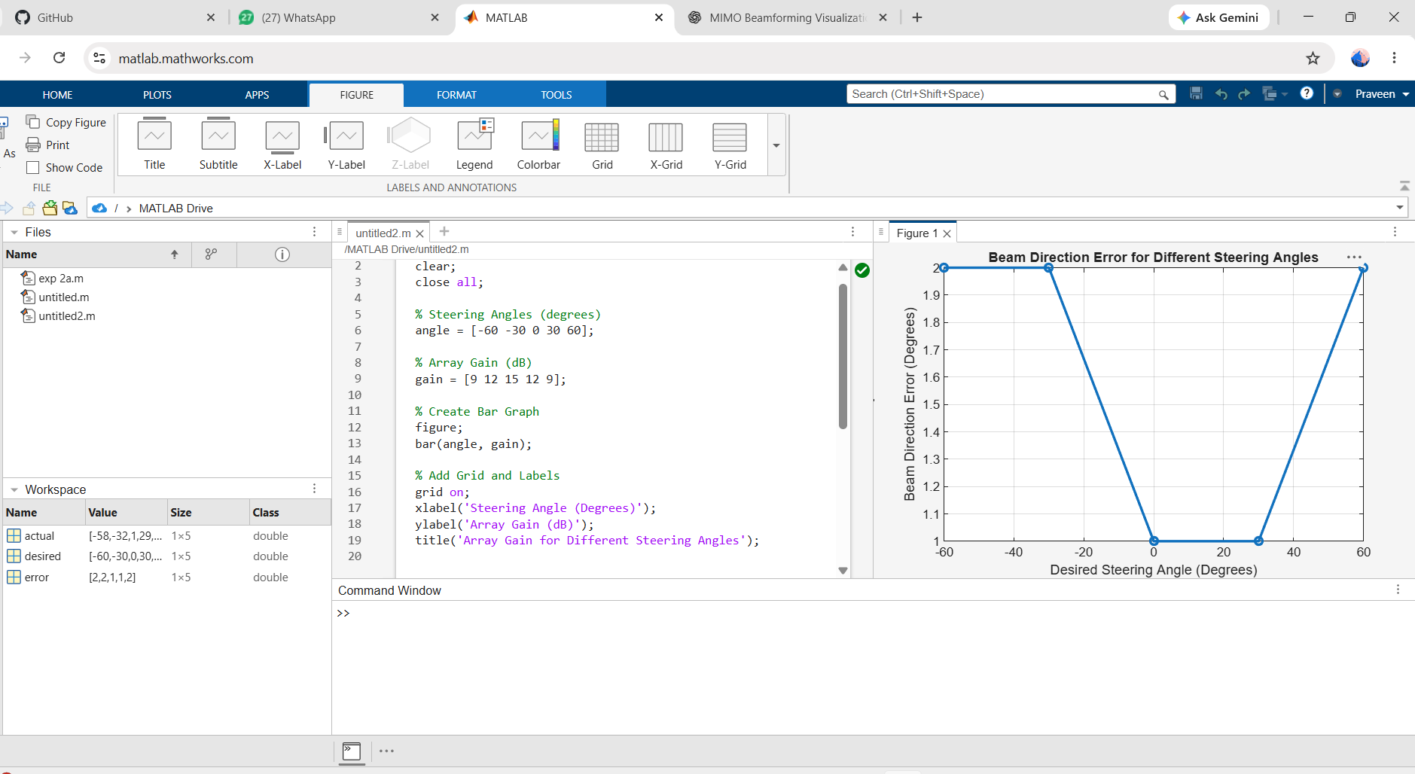

EXP 9
clc;
clear;
close all;

% SNR values in dB
snr = 0:5:30;

% Convert SNR from dB to linear scale
snr_linear = 10.^(snr/10);

% Calculate Channel Capacity (bps/Hz)
capacity = log2(1 + snr_linear);

% Plot Channel Capacity vs SNR
figure;
plot(snr, capacity, '-o', 'LineWidth', 2, 'MarkerSize', 6);

grid on;
xlabel('SNR (dB)');
ylabel('Channel Capacity (bps/Hz)');
title('Channel Capacity vs SNR');
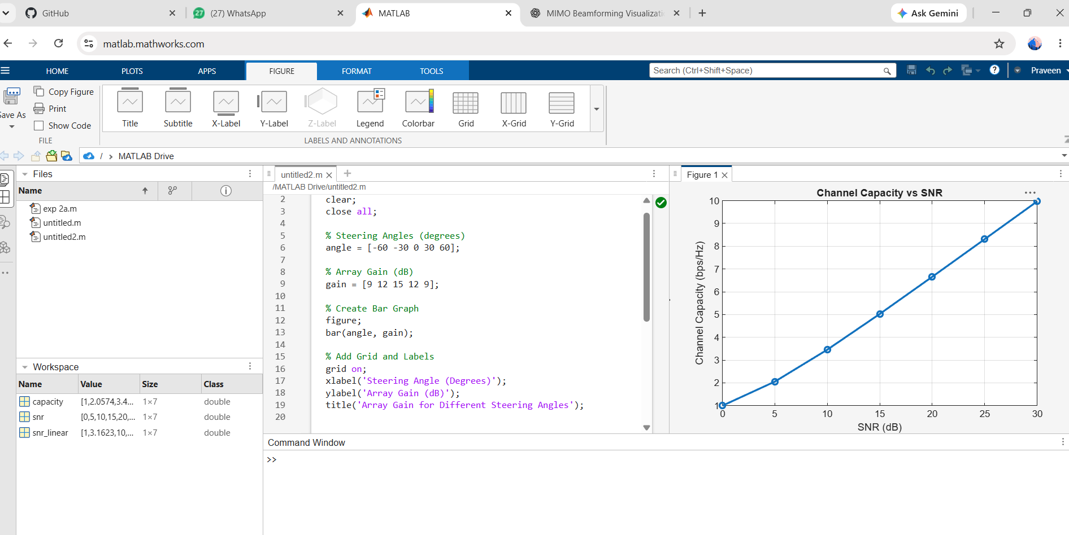

OBJ 2
clc;
clear;
close all;

% SNR values (dB)
snr = 0:5:30;

% Convert SNR from dB to linear scale
snr_linear = 10.^(snr/10);

% Calculate Channel Capacity (bps/Hz)
capacity = log2(1 + snr_linear);

% Plot the graph
figure;
plot(snr, capacity, '-o', 'LineWidth', 2, 'MarkerSize', 6);

grid on;
xlabel('SNR (dB)');
ylabel('Channel Capacity (bps/Hz)');
title('Channel Capacity vs SNR');
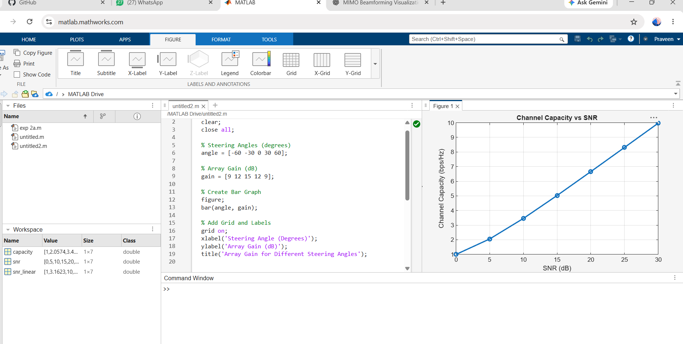
OBJ 3
clc;
clear;
close all;

% Number of Antenna Elements
antennas = [4 8 16 32 64];

% Antenna Gain (dB)
gain = 10 * log10(antennas);

% Plot Bar Graph
figure;
bar(antennas, gain);

grid on;
xlabel('Number of Antenna Elements');
ylabel('Antenna Gain (dB)');
title('Antenna Gain for Different Antenna Array Sizes');
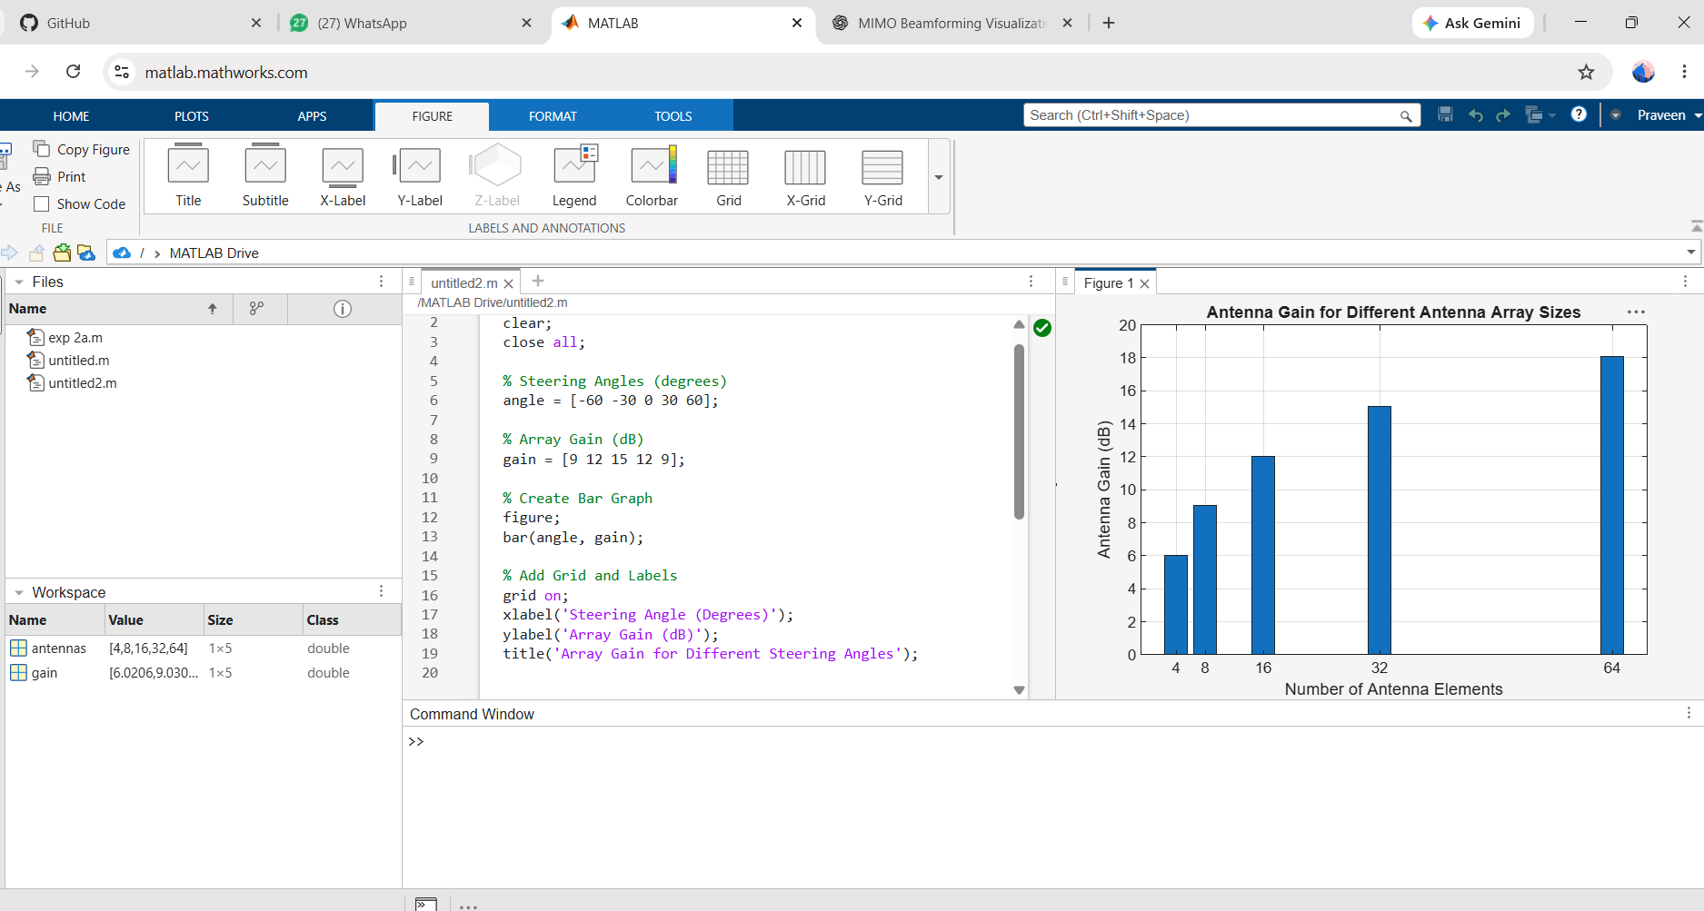

EXP 10
clc;
clear;
close all;

% Network Slice Types
slices = {'eMBB','URLLC','mMTC','Private','IoT'};

% Number of Instances for Each Slice
count = [1 1 1 1 1];

% Plot Bar Graph
figure;
bar(count);

grid on;
set(gca, 'XTickLabel', slices);

xlabel('Network Slice Type');
ylabel('Number of Network Slices');
title('Number of Configured 5G Network Slices');
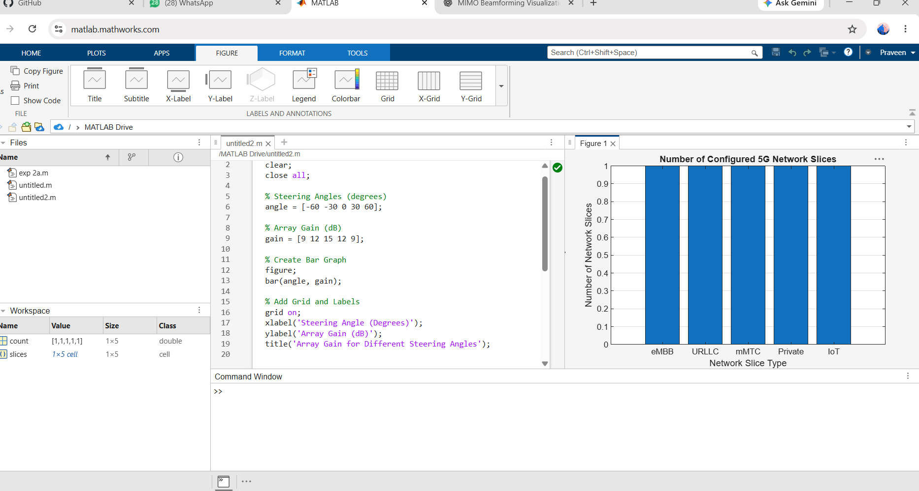

OBJ 2
clc;
clear;
close all;

% Network Slice Types
slices = categorical({'eMBB','URLLC','mMTC','Private','IoT'});

% Slice Utilization (%)
utilization = [85 70 60 75 50];

% Plot Bar Graph
figure;
bar(slices, utilization);

grid on;
xlabel('Network Slice Type');
ylabel('Slice Utilization (%)');
title('Slice Utilization in 5G Network Slicing');
ylim([0 100]);
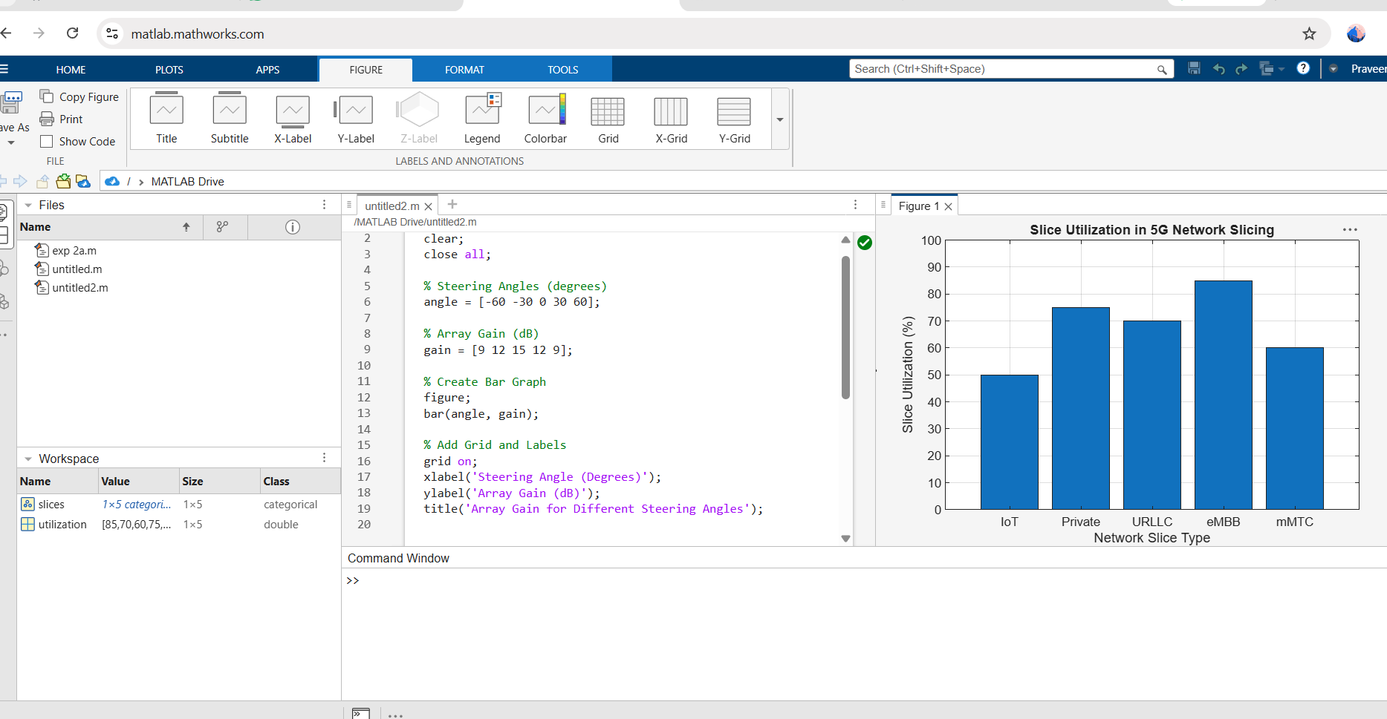

OBJ 3
clc;
clear;
close all;

% Network Slice Types
slices = [1 2 3 4 5];

% End-to-End Latency (ms)
latency = [25 5 40 15 60];

% Plot Line Graph
figure;
plot(slices, latency, '-o', 'LineWidth', 2, 'MarkerSize', 8);

grid on;
xticks(slices);
xticklabels({'eMBB','URLLC','mMTC','Private','IoT'});

xlabel('Network Slice Type');
ylabel('End-to-End Latency (ms)');
title('5G Network Slicing: End-to-End Latency');

ylim([0 70]);
